For National Public Safety Telecommunicators Week, we honor our *first* first responders, our country’s incredible 911 professionals. They’re the first voice heard in a moment of crisis, our lifelines, our calm in the chaos, providing unwavering support for the public and the emergency responders they work alongside. On April 13-19, please join us in recognizing their dedication and all they do to keep our nation safe.

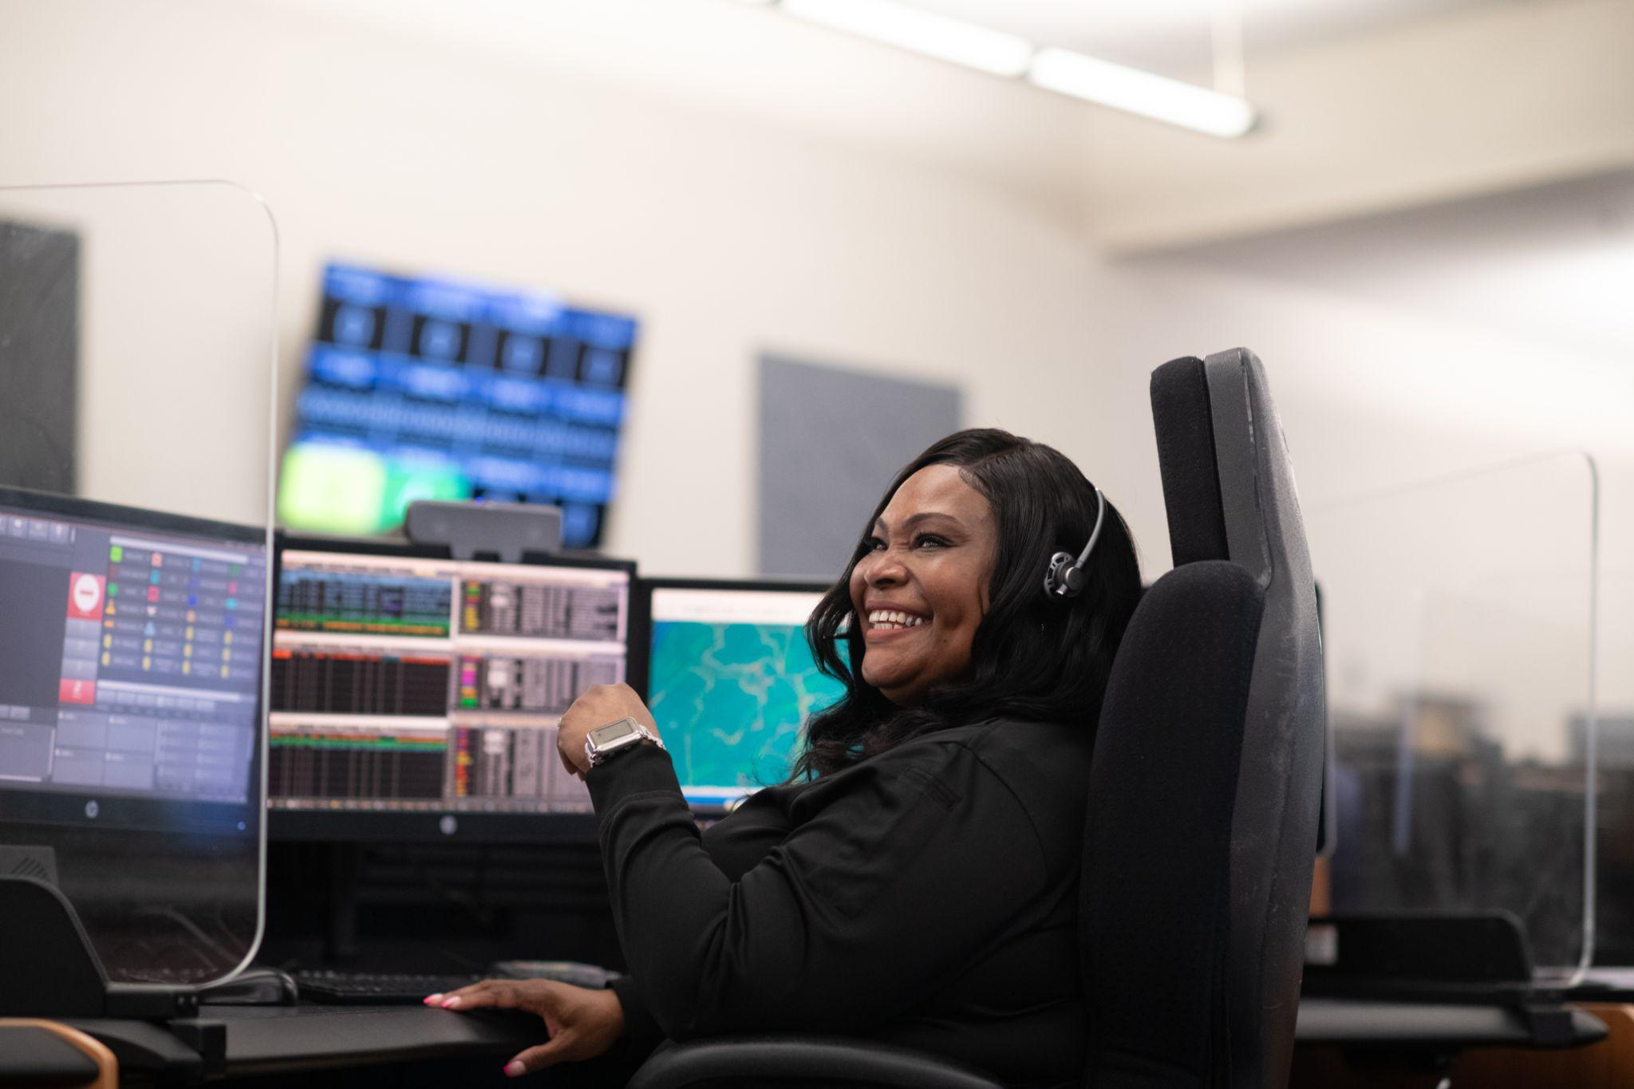

This National Public Safety Telecommunicators Week, we celebrate our nation’s resilient 911 professionals. Whether it’s a life threatening emergency or a call for reassurance in a moment of fear, their decisions, compassion and precision make a lasting impact. We thank them for their dedication to public safety, their colleagues and their communities.

