The NHTSA National 911 Program recognizes the exceptional skill, dedication and service of

911 Center

CITY, STATE

Brian Tegtmeyer Coordinator, National 911 Program

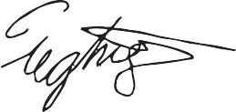

National Highway Traffic Safety Administration

Joni Harvey

Deputy Coordinator, National 911 Program National Highway Traffic Safety Administration

911 Center Director